KMP and Boyre Moore Algorithm

Report:

**Assumption :**

Data in DNA file is in upper case.

**Design Method:**

KMP and Boyer Morris Algorithm

**Programming language** :

Python

**Why Python?**

Easy to implement and have good environment for Data Anaylsis.

**Result** :

The Time taken by different algorithm w.r.t different pattern on same DNA text (data) graph:

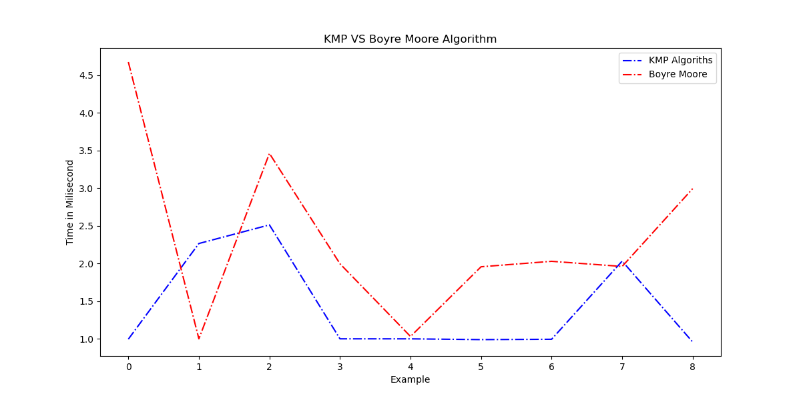

Time taken by KMP VS Boyer Morris Algorithm millisecond for different example on same data. At some condition Boyer Moore work better than KMP.

Time Complexity of KMP : O(M + N)

Space Complexity of KMP : O(M+N)

Time Complexity of Boyer Morris Algorithm: O(MN)

Space Complexity of Boyer Morris Algorithm: O(M+N)